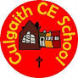Art and Design Subject Leader File

Intent
At Culgaith, we believe art and design provides the children with the opportunities to develop and extend their skills and an opportunity to express their individual interests, thoughts and ideas. Art is promoted in school to be enjoyable and that everyone’s opinions and interpretation of the different aspects are valued and important. Children have opportunities to learn about and develop their skills in various areas, including; collage, paint, 3D structure, printing and ICT.

Our curriculum map is structured through a sequence of units of work over two years, which link to our half term topics, which allows and ensures there are opportunities to experience and develop a structured progression of skills and knowledge that builds upon children’s prior learning and experiences. Each year, children will learn about a variety of artists and the artist will underpin the style of art the children will study.

Recently, we completed a textiles project based on our oceans topic, using recycled materials, the children created individual, multimedia pieces of artwork. The children explored different designs, patterns, colours, themes and analysed the work of Alice Kettle. We linked with a local artist, Kay Leech, who shared her sketchbooks and skills. They developed their sketching, monoprinting and stitching skills.
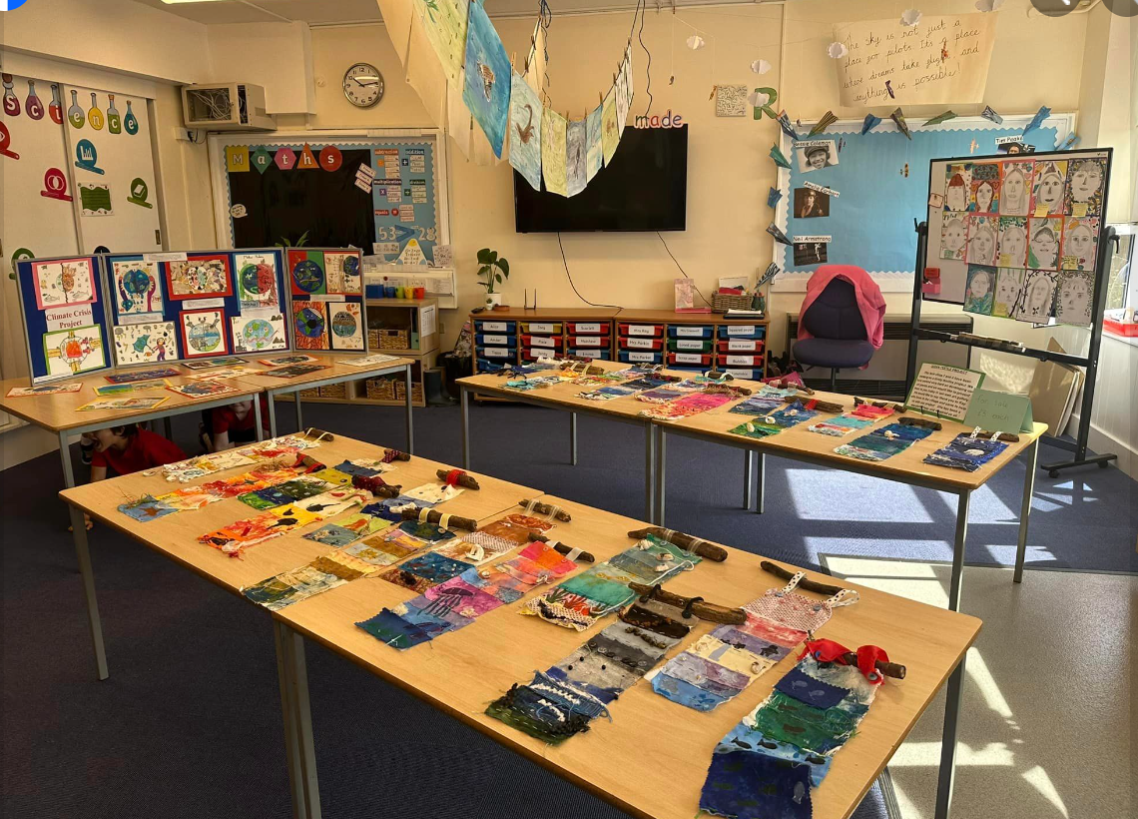 Our Art exhibition 2024 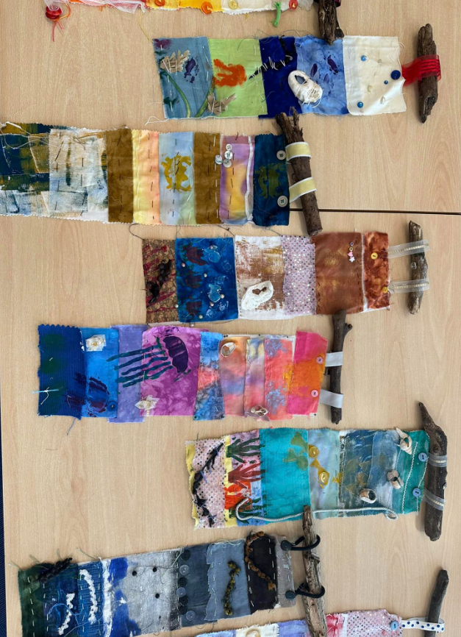 Textile pieces
Implementation
Our Art and Design curriculum has been designed following the National Curriculum for KS1 and KS2, and The Early Years Foundation Stage Framework. The Art and Design overview is bespoke to our school and our topics, so where possible, links have been made to the teaching of skills and learning about Artists, including those of our local area.

The progression of skills and vocabulary documents ensure all objectives are covered and the skills taught are progressive through the year groups. It means children are able to practise and develop mastery in the key processes of art and design: drawing, painting, printing, textiles and sculpture and create individualised pieces of artwork linked with the overarching topic. To ensure the correct level of challenge and accessibility for all children, teachers will use both documents to ensure lessons are correctly pitched.
Impact
The impact of our plans is that children at Culgaith School will develop a love of art, design and craft.
Children will embrace their sketchbooks and use them for recording their ideas, their thinking, their evaluations, their experimentation, as well as their individuality. Children feel confident about making mistakes and these should be valued as part of the working process. Feedback is given verbally, rather than written, the sketchbooks are respected as a child’s personal thinking space, however, the progression of art skills should be clear to see, as well as clearly highlighting the long term plan we are following.

Children will be confident in analysing their work and giving their opinion on their own and other works of art. Teacher’s will ensure the end goal is clear and appropriate steps are put in place to ensure these can be reached. All children will be able to speak confidently about their art and design work and their skills. Planning will demonstrate a progression of objectives when revisiting and reinforcing existing learning, knowledge and skills as well as providing continual challenge when appropriate.
Through our creative planning, sequencing, knowledge organisers, focused artists and celebration of each individual's creativity, we hope to engage, inspire and challenge pupils, equipping them with the knowledge and skills to experiment, invent and create their own works of art, craft and design.
Class 1 Overview

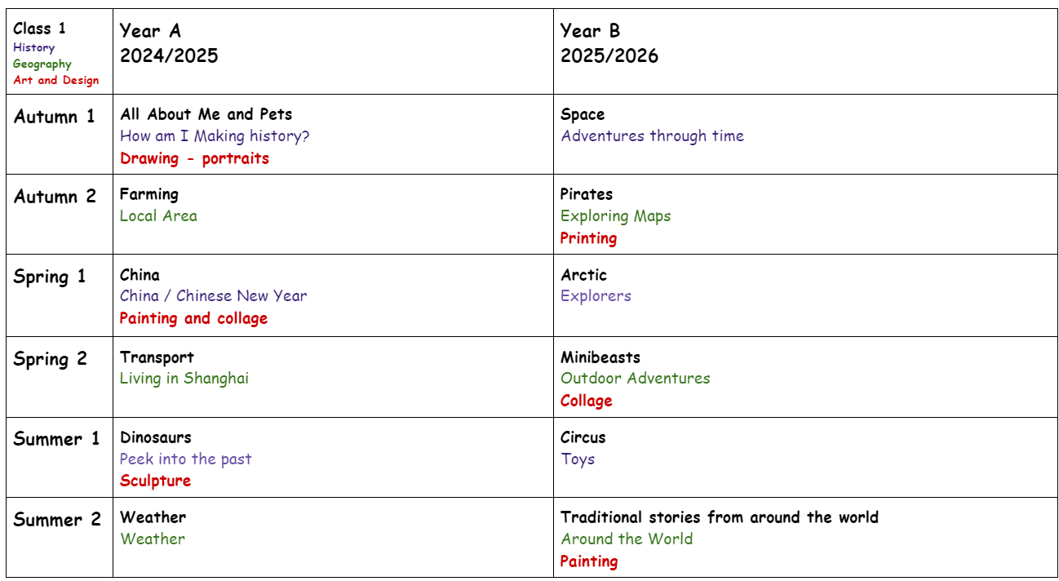

Class 2 Overview
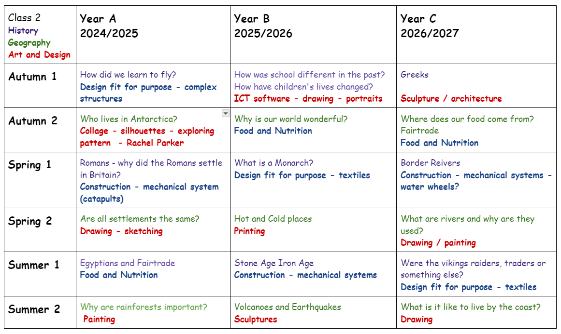

Class 3 Overview
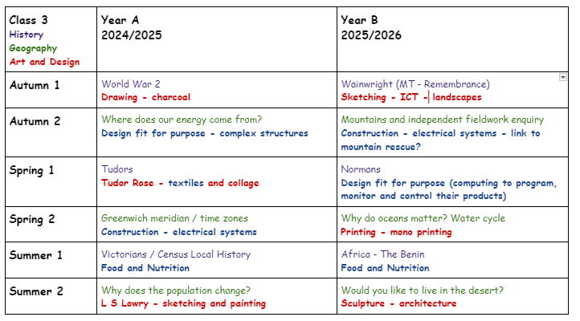

National Curriculum
EYFS: Expressive Arts and Designs
Imagination and Creativity:
- Imagination and creativity are children’s unique response to what they see, hear and experience around them
- Children have a natural curiosity to explore experiences. Non-verbal and verbal creative expression must be valued and noticed.
- Repetition allows children to explore and make sense of their experiences and to respond in their own unique way.
Self Expression:
- Exploring materials helps children to express themselves and communicate their thoughts, actions and ideas in many different ways.
- A good range of quality materials will help children develop their creativity.
- You can use found materials as well as more traditional bought art materials.
- Children’s interaction and exploration with materials supports their wider knowledge and understanding of the world around them.
- When you speak to the child about what they’re doing, use rich descriptive language.
Communicating through Art:
- Expression is the ability to communicate through arts.
- Artistic expression communicates something about children’s ‘self’, their preferences, interests, feelings, own experiences and choices.
- Provide art materials as early as possible. All children can communicate meaning through their responses to materials and experiences. This includes those without language, with English as an additional language or special educational needs (SEND).
- How you respond to children’s expression will affect their willingness to continue to develop that expression.
- The expressive arts support children’s wellbeing and has the potential for very young children to be highly involved for long periods of time.

Key stage 1
Pupils should be taught:
- to use a range of materials creatively to design and make products
- to use drawing, painting and sculpture to develop and share their ideas, experiences and imagination
- to develop a wide range of art and design techniques in using colour, pattern, texture, line, shape, form and space
- about the work of a range of artists, craft makers and designers, describing the differences and similarities between different practices and disciplines, and making links to their own work.

Key stage 2
Pupils should be taught to develop their techniques, including their control and their use of materials, with creativity, experimentation and an increasing awareness of different kinds of art, craft and design.
Pupils should be taught:
- to create sketch books to record their observations and use them to review and revisit ideas
- to improve their mastery of art and design techniques, including drawing, painting and sculpture with a range of materials [for example, pencil, charcoal, paint, clay]
- about great artists, architects and designers in history.

Progression of skills in Art and Design for EYFS, KS1 and KS2
 | EYFS | Year 1 | Year 2 | Year 3 | Year 4 | Year 5 | Year 6 | Suggested artists
Drawing  (pencil, charcoal, inks, chalk, pastels, ICT  software) | − Begin to use a variety of drawing tools  − Use drawings to tell a story Investigate  different lines  − Explore different  textures Encourage  accurate drawings of  people | − Extend the variety of drawings tools  − Explore different  textures  − Observe and draw  landscapes  − Observe patterns  − observe anatomy (faces, limbs) | − experiment with tools and surfaces  − draw a way of recording experiences and feelings  − discuss use of shadows, use of light and dark  − Sketch to make quick records | − Experiment with the  potential of various  pencils  − close observation  − Draw both the positive and negative shapes  − initial sketches as a  preparation for painting  − accurate drawings of people – particularly  faces | − Identify and draw the effect of light  − scale and proportion  − accurate drawings of whole people including  proportion and  placement  − Work on a variety of  scales  − computer generated drawings | − effect of light on objects and people from  different directions  − interpret the texture of a surface  − produce increasingly accurate drawings of  people  − concept of perspective | − effect of light on objects and people from  different directions  − interpret the texture of a surface  − produce increasingly accurate drawings of  people  − concept of perspective | Leonardo Da Vinci, Vincent Van Gogh, Poonac
Colour  (painting, ink, dye,  textiles, pencils, crayon, pastels) | − Experimenting with and using primary colours  − Naming  − mixing (not formal)  − Learn the names of  different tools that bring colour  − Use a range of tools to make coloured marks on paper | − name all the colours  − mixing of colours  − Find collections of colour − applying colour with a range of tools | − Begin to describe colours by objects  − Make as many tones of one colour as possible  (using white)  − Darken colours without using black  − using colour on a large scale | − colour mixing  − Make colour wheels  − Introduce different types of brushes  − techniques- apply colour using dotting, scratching, splashing | − - colour mixing and  matching; tint, tone,  shade  − - observe colours  − - suitable equipment for the task  − - colour to reflect mood | − hue, tint, tone, shades and mood  − explore the use of  texture in colour  − colour for purposes  −  − | − hue, tint, tone, shades and mood  − explore the use of  texture in colour  − colour for purposes  − colour to express  feelings | Pollock, Monet, Chagall, Ben Moseley,  Van Gogh,
Texture  (textiles, clay, sand,  plaster, stone) | − Handling, manipulating and enjoying using  materials  − Sensory experience  − Simple collages  − simple weaving | − weaving  − collage  − Sort according to specific qualities  − how textiles create  things | − overlapping and  overlaying to create  effects  − Use large eyed needles – running stitches  − Simple appliqué work − Start to explore other simple stitches  − collage | − Use smaller eyed  needles and finer  threads  − weaving  − Tie dying, batik  − | − Use a wider variety of stitches  − observation and design of textural art  − experimenting with  creating mood, feeling,  movement-  − compare different  fabrics | − use stories, music,  poems as stimuli  − Select and use materials − embellish work  − fabric making  − artists using textiles | − Develops experience in embellishing  − Applies knowledge of different techniques to  express feelings  − Work collaboratively on a larger scale | Linda Caverley, Molly  Williams, William Morris, Gustav Klimt
Form  (3D work, clay, dough, boxes, wire, paper  sculpture, mod roc ) | − Handling, feeling,  enjoying and  manipulating materials  − Constructing  − Building and destroying − Shape and model | − Construct  − Use materials to make known objects for a  purpose  − Carve  − Pinch and roll coils and slabs using a modelling  media.  − Make simple joins | − Awareness of natural and man-made forms  − Expression of personal experiences and ideas  − to shape and form from direct observation  (malleable and rigid  materials)  − decorative techniques − Replicate patterns and textures in a 3-D form  − work and that of other sculptors | − Shape, form, model and construct ( malleable  and rigid materials)  − Plan and develop  − understanding of  different adhesives and  methods of construction  − aesthetics | − Plan and develop  − Experience surface  patterns / textures  − Discuss own work and work of other sculptors  − analyse and interpret natural and manmade  forms of construction | − plan and develop ideas − Shape, form, model and join  − observation or  imagination  − properties of media  − Discuss and evaluate own work and that of  other sculptors | − plan and develop ideas − Shape, form, model and join  − observation or  imagination  − properties of media  − Discuss and evaluate own work and that of  other sculptors | Henry Moore, Barbara  Hepworth, Andy  Goldsworthy,
Printing  (found materials,  fruit/veg, wood blocks, press print, lino, string) | − Rubbings  − Print with variety of  objects  − Print with block colours | − Create patterns  − Develop impressed  images  − Relief printing | − Print with a growing  range of objects  − Identify the different forms printing takes | − relief and impressed  printing  − recording  textures/patterns  − monoprinting  − colour mixing through overlapping colour prints | − Use sketchbook for  recording  textures/patterns  − Interpret environmental and manmade patterns  − modify and adapt print | − combining prints  − design prints  − make connections  − discuss and evaluate own work and that of  others | − Builds up drawings and images of whole or parts of items using various  techniques  − Screen printing  − Explore printing  techniques used by  various artists | Picasso, Dan Mather, Andy Warhol
Pattern  ( paint, pencil, textiles, clay, printing) | − repeating patterns  − irregular painting  patterns  − Simple symmetry | − Awareness and  discussion of patterns  − repeating patterns  − symmetry | − Experiment by arranging, folding, repeating,  overlapping, regular and irregular patterning  − natural and manmade patterns  − Discuss regular and  irregular | − pattern in the  environment  − design  − using ICT  − make patterns on a  range of surfaces  − symmetry | − Explore environmental and manmade patterns  − tessellation | − Create own abstract  pattern to reflect  personal experiences  and expression  − create pattern for  purposes | − Create own abstract  pattern to reflect  personal experiences  and expression  − create pattern for  purposes | Joan Miro, Bridget Riley, Escher, Paul Klee,

Year Progression in Art Vocabulary from EYFS to Year 6.
EYFS: Colour, marks, lines, space, texture, smooth, shiny, rough, prickly, flat, patterned, jagged, bumpy, soft and hard, wet, dry, flaky, fixed, mix, cut, sweep.
Year 1:
Drawing: Thick, Thin, Soft, Broad, Narrow, Fine, Pattern, Line, Shape, Detail, Mirror image, Nature, Made environment. Painting: Primary (colour), Light, Dark, Thick, Thin, Tone, Warm, Cold, Shade e.g. different shades of red, green, blue, yellow, Bright. Printing: Print, Rubbing, Smudge, Image, Reverse, Shapes, Surface, Pressure, Decoration, Cloth. Collage & Textiles: Fabric, Colour, Pattern, Shape, Texture, Glue, Stick, Scissors, Sew, Needle, Felt, Hessian, Scraps, Wool, Yarn, Thread, Fur, Tweed, Silk, Satin, Net, Weave. Sculpture: Model, Cut, Stick, Fold, Bend, Attach, Assemble, Statue, Stone, Shell, Wood, metal, texture, construct
Year 2:
Drawing: Thick, Thin, Soft, Broad, Narrow, Fine, Pattern, Line, Shape, Detail, Nature, Made environment, Comparison, Still life. Painting: Secondary (colour), Light, Dark, Thick, Thin, Tone, Warm, Cold, Shade e.g. different shades of red, green, blue, yellow, Bright, Pointillism, Colour wash. Printing: Print, Rubbing, Smudge, Image, Reverse, Shapes, Surface, Pressure, Decoration, Cloth, Repeat, Rotate, Mon-print, Two-tone print. Collage & Textiles: Fabric, Colour, Pattern, Shape, Texture, Glue, Stick, Scissors, Sew, Needle, Felt, Hessian, Scraps, Wool, Yarn, Mixed media, Collage, Appliqué, Layers, Combine, Opinion, Thread, Fur, Tweed, Silk, Satin, Net, Weave. Sculpture: Sculpture, Structure, Assemble, Construct, Model, Fold, Bend, Attach, Statue, Stone, Metal, Curve, Form, Clay, Impress, Texture
Year 3 and 4:
Drawing: Plan, Distance, Direction, Position, Form, Texture, Tone, Weight, Pressure, Portrait, Past, Present, Appearance, Character, Personality. Painting: Scenery, Rural, Urban, Townscape, Seascape, Representational, Imaginary, Impressionist, Abstract, Idealised, Natural, Swirling, Stippled, Transparent, Opaque, Foreground, Background, Middle ground, Horizon Printing: Imprint, Impression, Monoprint, Background, Marbling, Surface, Absorb, Stencil, Pounce, Negative image, Positive image. Collage & Textiles: Tie and dye, Natural, Synthetic, Vat, Bunching, Dip, Soak, Resist, Threading, Stitching, Embroidery, Cross stitch, Running stitch, Stem stitch, Shrunken, Wool tops, Carding, Tease, Matting. Sculpture: Viewpoint, Detail, Decoration, Natural, Form, Two-dimensional, Three-dimensional, Tiles, Wood, Stone, Metal, Texture, Proportion, Symbolic
Year 5 and 6:
Drawing: Viewpoint, Distance, Direction, Angle, Perspective, Bird’s eye view, Alter, Modify, Interior, Exterior, Natural form, Vista, Panorama, Image, Subject, Portrait, Caricature, Expression, Personality.
Painting: Traditional, Representational, Imaginary, Modern, Abstract, Impressionist, Stippled, Splattered, Dabbed, Scraped, Dotted, Stroked, Textured, Flat, Layered, Opaque, Translucent, Intense.
Printing: Monotype, Printing plate, Inking up, Water-based, Oil-based, Overlap, Intaglio, Relief, Etching, Engraving, Indentation, Collograph, Pressure.
Collage & Textiles: Cloth, Fray, Taffeta, Organdie, Poplin, Tweed, Embellished, Manipulated, Embroidered, Warp, Weft, Replicate, Soft sculpture, Repetition
Sculpture: Realistic, Proportion, Surface texture, Balance, Scale, Relationship, Transform, Movement, Rhythm, Composition, Structure, Construct, Flexible, Pliable, Hollow, Solid, Surface, Plane, Angle, Slip, Attachment, Relie

Curriculum Map

Class 1 - EYFS and Year 1 | All About Me  Drawing | China  Painting  And collage | Dinosaurs  Sculpture | Pirates  Printing  and Form | Minibeasts  Drawing | Traditional Stories  Painting
Drawing -  Extend the variety of drawings tools  − Explore different textures  − Observe and draw landscapes  − Observe patterns  − observe anatomy (faces, limbs) | / |  |  |  | /
Colour -  Name all the colours  − mixing of colours  − Find collections of colour  − applying colour with a range of tools |  | / |  | / | / | /
Texture / Collage  - weaving  − collage  − Sort according to specific qualities  − how textiles create  things |  | /
Form / sculpture -  Construct  − Use materials to make known objects for a purpose  − Pinch and roll coils and slabs using a modelling media.  − Make simple joins |  |  | / | /
Printing / painting -  Create patterns  − Develop impressed  images  − Relief printing |  | / |  | / |  | /
Pattern  Awareness and discussion of patterns  − repeating patterns  − symmetry |  | / |  |  | /

Class 2 - Year 2,3 and 4 | Antarctica | Settlements | Rainforests | Schools | Hot and Cold Places | Volcanoes and Earthquakes | Greeks | Rivers | Coasts
To create sketch books to record their observations and use them to review and revisit their ideas | / | / | / | / | / | / | / | / | /
To improve their mastery of drawing |  | / |  | / |  |  |  |  | /
To improve their mastery of painting and printing |  |  | / |  | / |  |  | /
To improve their mastery of sculpture with a range of materials |  |  |  |  |  | / | /
To learn about great artists, architects and designers in history | / | / | / | / | / | / | / | / | /
To improve their mastery of collage | / |  |  |  |  |  |  |  | /

Class 3 - Year 5 and 6 | WW2  Drawing | Tudor  Textiles and Collage | Population  Sketching and Painting | Wainwright  Drawing / ICT | Oceans  Printing | Desert  Sculpture
To create sketch books to record their observations and use them to review and revisit their ideas | / | / | / | / | / | /
To improve their mastery of drawing | / |  | / | / | /
To improve their mastery of painting and printing |  |  | / |  | /
To improve their mastery of sculpture with a range of materials |  |  |  |  |  | /
To learn about great artists, architects and designers in history | / | / | / | / | / | /
To improve their mastery of collage |  | /

